

**Downloadable DRM Solution for Multimedia Streaming applications - High Level Design**

**Revision History**

Table of Contents

Table of Contents 3

Abbreviations 4

1. Introduction to DRM 5

2. Goals and Objectives 8

3. Solution Overview 9

4. System Architecture 10

5. Code Flow 11

# Abbreviations

DRM Digital Rights Management

OCDM Open Content Decryption Module

CDM Content Decryption Module

GST GStreamer

MM Multimedia

SS Smooth Streaming

HLS Http Live Streaming

CA Client Application

TA Trusted Application

NSW Non Secure World

SW Secure World

VSF Votary Secure Framework

TEE TrustZone Execution Environment

# Introduction to DRM

Digital rights management (DRM) is a type of access control technology used to protect and license digital intellectual property. It is used by publishers, manufacturers, copyright holders and IP owners for digital content and device monitoring. DRM software prevents the consumer from copying content or converting it to other formats.

A DRM scheme operates on three levels: establishing a copyright for a piece of content, managing the distribution of that copyrighted content and controlling what a consumer can do with that content once it has been distributed. To accomplish this level of control, a DRM program has to effectively define and describe three entities -- the user, the content and the usage rights -- and the relationship between them. As DRM becomes standardized across industries, the result will be what experts call "trusted computing."

Leading DRM Platforms:

As with many platform technologies, DRM software is quite fragmented in the desktop, OTT and mobile space. The rapid spread of the new HTML5 video format is also complicating a single reliable DRM system to meet the copyright holder requirements. While it would be ideal to have a unified DRM technology that can cover the widest range of use cases, there is not one universal platform for all devices and not one common standard. However, the most widely used content protection tools in the online video space are Google Widevine, Microsoft PlayReady, Adobe Primetime, Apple FairPlay and Verimatrix.

Encrypted Media Extensions:

This API based encryption scheme is not tied to any specific vendor or DRM scheme, and has become an emerging means of encrypting HTML5 video, including adaptive bitrate video within HTML5.

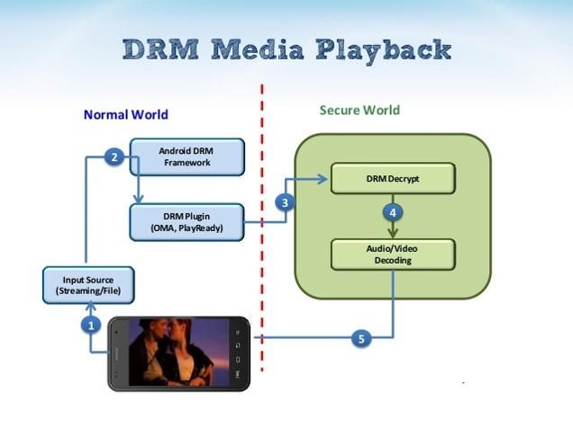

**Fig1.a: Basic DRM Media Playback flow**

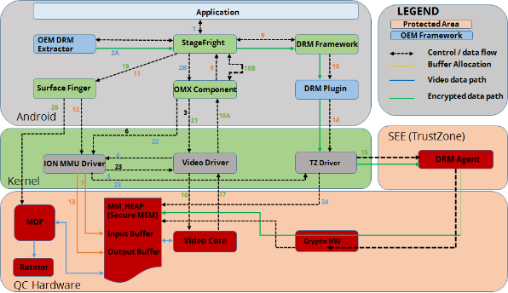

**Fig1.b: An example DRM processing in Android system**

# Goals and Objectives

Objectives of Multimedia Secure Streaming solution based on downloadable DRM are:

* Ability to identify DRM type and to extend support for client side media player.
* Multimedia streaming solution could able to download custom DRM plugin to support playback
* This could help an existing media player to extend for new DRM types.
* Ensures the media playback abides with secure measures to maintain data integrity.
* Design of this DRM framework is agnostic and abstracts specific DRM scheme.

# Solution Overview

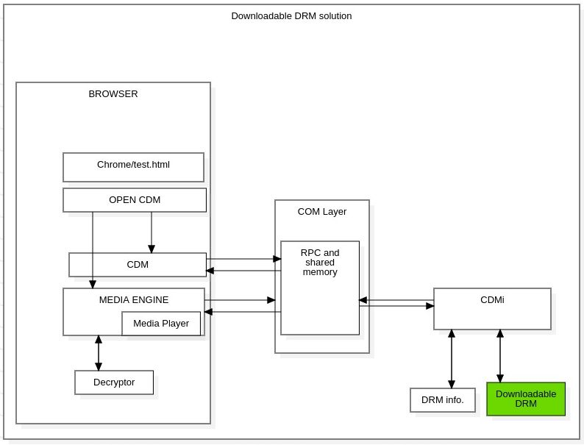

**Fig2.1: Block diagram of Downloadable DRM Solution based on OCDM framework**

# System Architecture

# Code Flow